1. **Introduction**

In the realm of professional cycling, the selection of bicycle frames holds immense significance for riders, as their performance and career success heavily rely on the equipment provided by their team's sponsors. While professional riders possess exceptional abilities surpassing those of amateur or recreational cyclists, the choice of bike frame becomes pivotal in achieving career-defining victories. With more wins or consistent performance, teams are likely to attract additional sponsors, securing increased funding and resources. Consequently, team budgets expand, leading to higher salaries for riders and staff members.

Considering the critical role of bike equipment in racing, two fundamental questions arise: *1) Which bike frames exhibit the most consistent performance? This inquiry aims to identify the bike frames that consistently excel based on race results. 2) What is the cost associated with having a higher probability of achieving a podium finish?* Addressing these questions necessitates analyzing race data from the Tour de France, Giro d'Italia, and Vuelta a España spanning the years 2020 to 2022. The analysis will involve examining the race results alongside the bike frames used by respective teams during each year. Subsequently, we will explore the implications of the findings for riders within teams, riders seeking team placements, potential investors, sponsors, and non-professional consumers.

1. **About the Data**

Race Results Dataset

The race results dataset used in this analysis includes data from the Tour de France, Giro d'Italia, and Vuelta a España, which are renowned as the Grand Tours and represent the pinnacle of professional cycling races. The dataset was obtained by scraping the race results from firstcycling.com.

It should be noted that the original data presented subsequent times as additional minutes and seconds to the first-place finisher's time (e.g., +3:04). However, when importing the data into Excel, it was interpreted as specific dates in a particular year rather than time durations. To address this issue, the times were corrected and converted into total minutes using the Python Pandas and datetime libraries within Visual Studio Code's Jupyter Notebook extension. The resulting dataset provided the total time in minutes for each rider (e.g., 243.07 mins).

To gain insights from the dataset and better understand the performance differences among riders, the positions and respective times of the riders from different teams were visualized using Power BI. This visualization enabled a comprehensive comparison of accumulated riders' times and highlighted variations between teams.

Team Bikes and Parts per Year

The dataset used in this analysis was sourced from various reliable sources, including official brand websites. In cases where certain parts were discontinued and no longer listed on the official websites, alternative sources were utilized. However, priority was given to information obtained directly from the official brand websites and their corresponding prices.

To ensure accurate comparisons, the prices were converted to Philippine pesos using Google's currency conversion rates on the day the data was scraped. The scraping process was performed in Visual Studio Code, utilizing the Python Pandas library. In some instances, data was manually added to the spreadsheets to ensure completeness and accuracy.

To explore the relationship between bike parts and team results, the data was visualized using Power BI. This visualization allowed for a clearer understanding of the connections and patterns between bike parts and their impact on team performance.

1. **Analysis**

Identifying the Most Consistently Performing Bike Frame

From 2020 to 2022, certain bike frames demonstrated consistent performance across the three races analyzed. In 2022, the S-Works Tarmac SL7 (Specialized), Colnago V4rs, and Pinarello Dogma F consistently secured top three positions in all three races. Additionally, these frames appeared in the top ten positions. Similarly, in 2021, the Cervelo S5, Merida Reacto, and Pinarello Dogma F consistently achieved top three positions and top ten positions. In 2020, the Bianchi Oltre XR4 and Pinarello Dogma F maintained a consistent presence in the top three, with the addition of the Specialized Venge in the top ten. Throughout the analyzed period, Specialized and Pinarello frames consistently performed well, securing top ten positions and frequently reaching the top three.

Investment Required for Top Three Performances

To secure at least a third-place finish in 2022, an approximate investment of ₱644,433.10, based on the average price of third-place bikes, would be necessary. The average price of the top three bikes from the races amounted to ₱667,591.78. Similarly, in 2021, an investment of ₱644,433.10 would be required for a third-place finish, with the average price of the top three bikes being ₱581,565.68. In 2020, an investment of ₱426,869.69 would be needed for at least a third-place finish, while the average price of the top three bikes amounted to ₱547,099.58.

Limitations of the Analysis

Several limitations should be considered when interpreting the findings of this analysis. Firstly, it assumes that factors such as rider skill and physical abilities are equal across all teams, with the bike frame being the sole differentiating factor. Team strategy and other unforeseen events, such as crashes, adverse weather conditions, or mechanical failures, can significantly impact race results, independent of the bike frame. These factors were not accounted for in the analysis and may influence the frequency of top three or top ten placements for a given race.

The three Grand Tour races from the last three years, show that the S-Works Tarmac SL7 from Specialized and the Dogma F from Pinarello, are the most consistent top performing bikes. These two were most often included in the Top 10 and Top 3 in the three races over from 2020-2022. The cost of having a bike that will most likely land in the Top 3 increased each year, with the average price of ₱555,128.16 in 2020, then ₱581,565.68 in 2021, and ₱647,369.56 during 2022. This means that a podium finishing bike would most likely be worth around ₱600,000 pesos from the average of the three. However, this price will probably increase for subsequent years, as observed from the last three years.

1. **Implications**

Rider

Professional riders competing in the Grand Tours may have an advantage if they are part of a team that utilizes Specialized or Pinarello bike frames. The consistent top ten and top three placements of these frames suggest that joining a team equipped with these frames could lead to a higher chance of success. This can be appealing to riders seeking team placement or looking to enhance their careers. Teams with successful performances are more likely to attract sponsors and investors, resulting in increased team budgets and potentially higher salaries for riders and staff.

Investors/Sponsors

Investors and sponsors can use the data to inform their decision-making process. Teams using Specialized or Pinarello frames consistently demonstrate strong performances in the Grand Tours. This information can help investors and sponsors focus their attention on teams equipped with these frames, as they have a higher probability of achieving successful race results. By supporting teams with proven track records, investors and sponsors can align their resources with potential winners.

Recreational Consumers

For non-professional cyclists or amateur-level racers, the analysis reveals that Specialized and Pinarello frames consistently produce winning results in the Grand Tours. This indicates that these frames offer reliable performance and justifies their price points. Choosing a Specialized or Pinarello frame can provide recreational cyclists with confidence that their equipment will not hinder their performance during races. It suggests that investing in these frames could contribute to a more enjoyable and competitive cycling experience.

1. **Conclusion**

In conclusion, the analysis of bike frames and race results in the Grand Tours provides valuable insights into the performance and cost considerations for riders, investors, sponsors, and recreational consumers. Specialized and Pinarello frames emerge as the most consistent performers, with frequent top ten and top three placements. Professional riders can benefit from joining teams that use these frames, as it increases their chances of success and attracts potential sponsors and investors. Investors and sponsors can make informed decisions by supporting teams equipped with Specialized or Pinarello frames, as these frames demonstrate a strong track record. For recreational cyclists, choosing Specialized or Pinarello frames ensures reliable performance during races and enhances their overall cycling experience. By understanding the implications of the analysis, stakeholders can make strategic choices to maximize their involvement in the cycling industry.

1. 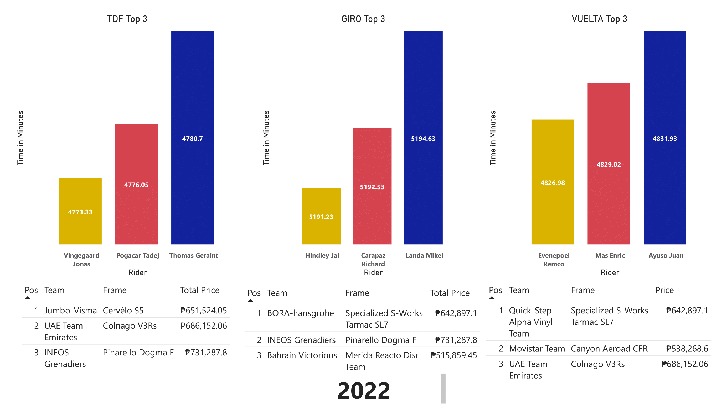**Appendix**

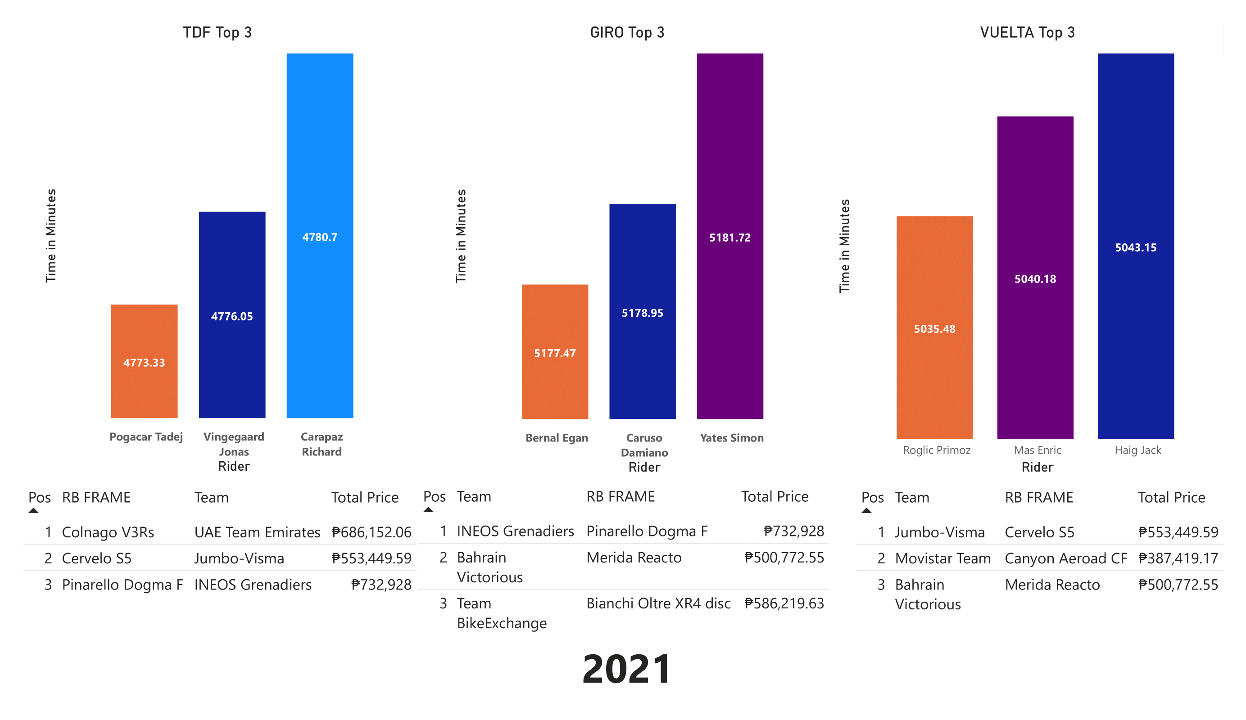

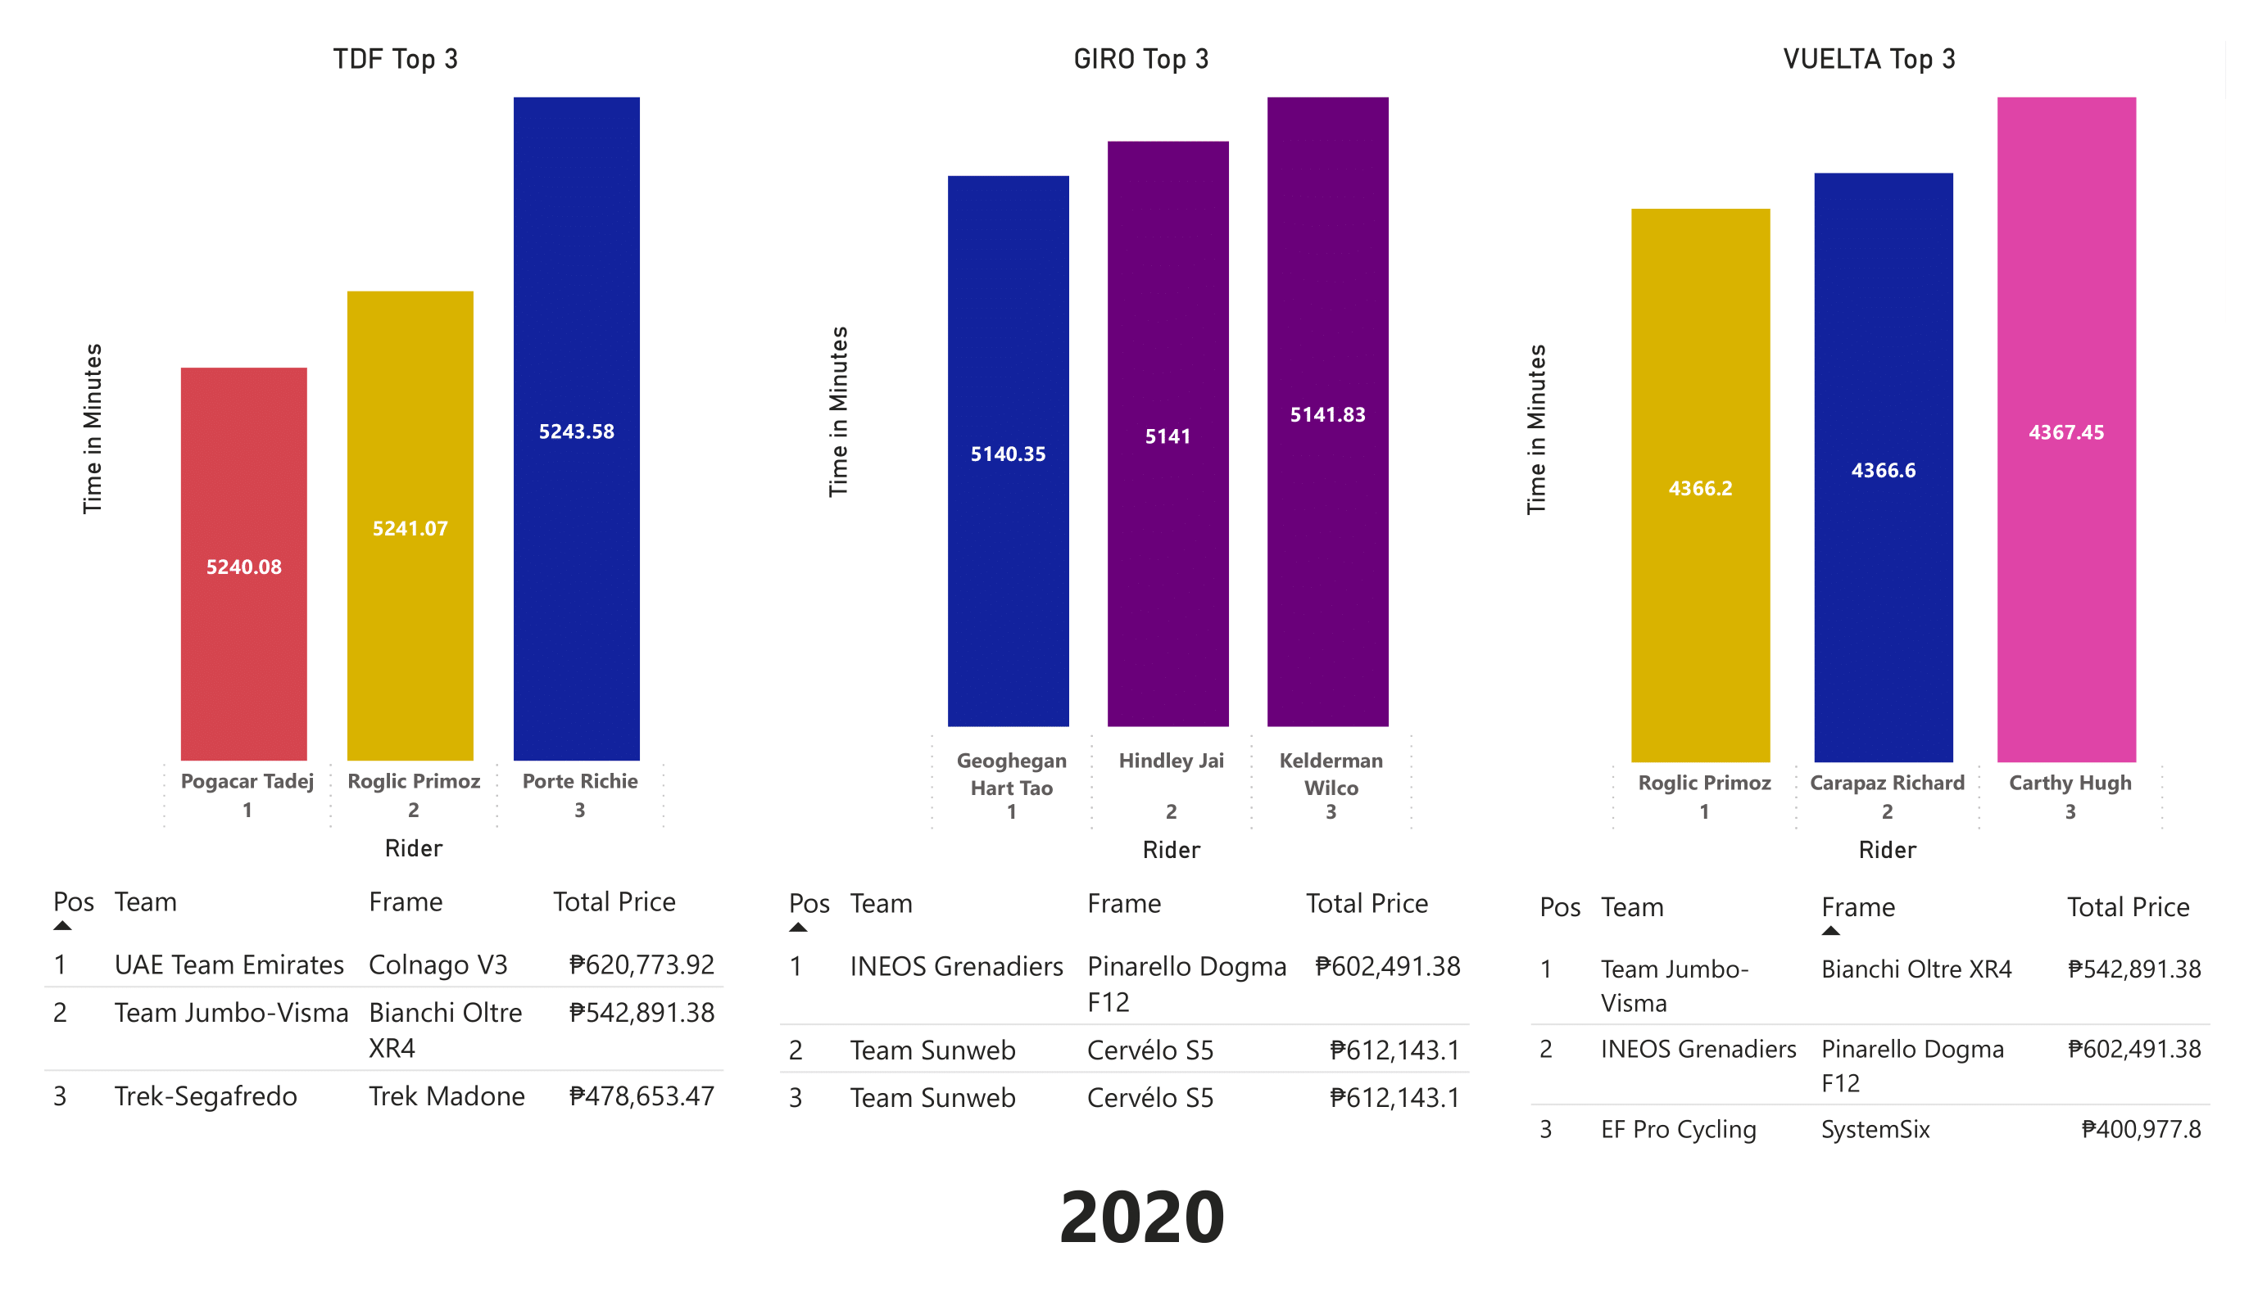

1. **References**

FirstCycling. (2022). Giro d'Italia 2022 - Results. Retrieved from

https://firstcycling.com/race.php?r=17&y=2022

FirstCycling. (2022). Tour de France 2022 - Results. Retrieved from

https://firstcycling.com/race.php?r=13&y=2022

FirstCycling. (2022). Vuelta a España 2022 - Results. Retrieved from

https://firstcycling.com/race.php?r=23&y=2022

FirstCycling. (2021). Giro d'Italia 2021 - Results. Retrieved from

https://firstcycling.com/race.php?r=17&y=2021

FirstCycling. (2021). Tour de France 2021 - Results. Retrieved from

https://firstcycling.com/race.php?r=13&y=2021

FirstCycling. (2021). Vuelta a España 2021 - Results. Retrieved from

https://firstcycling.com/race.php?r=23&y=2021

FirstCycling. (2020). Giro d'Italia 2020 - Results. Retrieved from

https://firstcycling.com/race.php?r=17&y=2020

FirstCycling. (2020). Tour de France 2020 - Results. Retrieved from

https://firstcycling.com/race.php?r=13&y=2020

FirstCycling. (2020). Vuelta a España 2020 - Results. Retrieved from

https://firstcycling.com/race.php?r=23&y=2020

BikeRadar. (2019, July 26). Tour de France bikes: winning machines from the peloton's biggest race.

Retrieved from https://www.bikeradar.com/features/pro-bike/tour-de-france-bikes/

Bike Room. (2022, February 17). World Tour bikes 2022 - Set-ups, details, photos and insights.

Retrieved from <https://bike-room.com/blog/world-tour-bikes-2022-set-ups-details->photos-and-insights/

Cyclingnews. (2021, February 16). WorldTour bikes and tech: Who's using what in 2021. Retrieved

from <https://www.cyclingnews.com/features/worldtour-bikes-and-tech-whos-using-> what-in-2021/

Velon. (2020, February 18). World Tour Pro Team Bikes 2020. Retrieved from

https://www.velon.cc/news/2020/2/18/world-tour-pro-team-bikes-2020

Wikipedia. (n.d.). List of 2021 UCI WorldTeams and riders. Retrieved May 12, 2023, from

https://en.wikipedia.org/wiki/List_of_2021_UCI_WorldTeams_and_riders#Teams_overview

CyclingTips. (2019, January 7). Pro bikes of the 2019 men's WorldTour. Retrieved from

https://www.cyclingtips.com/2019/01/pro-bikes-of-the-2019-mens-worldtour/

BikeExchange. (2019, January 22). Pro bikes of the 2019 World Tour peloton. Retrieved from

https://www.bikeexchange.com/blog/pro-bikes-of-the-2019-world-tour-peloton

CyclingTips. (2019, January 7). Pro bikes of the 2019 men's WorldTour. Retrieved from

https://www.cyclingtips.com/2019/01/pro-bikes-of-the-2019-m